

МИНИСТЕРСТВО НАУКИ И ВЫСШЕГО ОБРАЗОВАНИЯ РОССИЙСКОЙ ФЕДЕРАЦИИ

**ФЕДЕРАЛЬНОЕ ГОСУДАРСТВЕННОЕ БЮДЖЕТНОЕ**

**ОБРАЗОВАТЕЛЬНОЕ УЧРЕЖДЕНИЕ ВЫСШЕГО ОБРАЗОВАНИЯ  
«ДОНСКОЙ ГОСУДАРСТВЕННЫЙ ТЕХНИЧЕСКИЙ УНИВЕРСИТЕТ»**

**(ДГТУ)**

Факультет «Информатика и вычислительная техника»

Кафедра «Кибербезопасность информационных систем»

**Лабораторная работa 4**

Выполнил:

Гр. ВКБ 31

Целиков А.О.

Проверил:

Савельев В.А.

Ростов-на-Дону,

2021г.

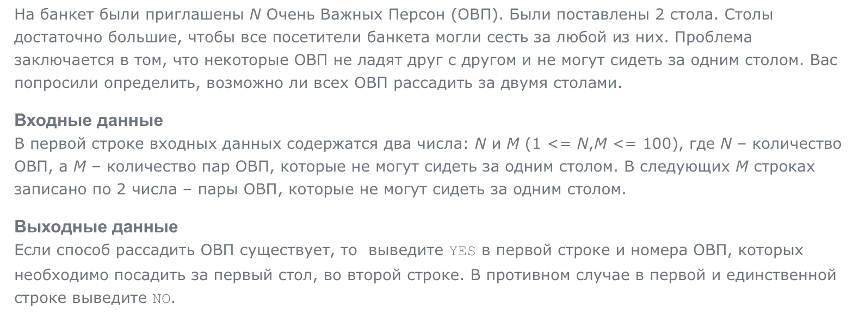

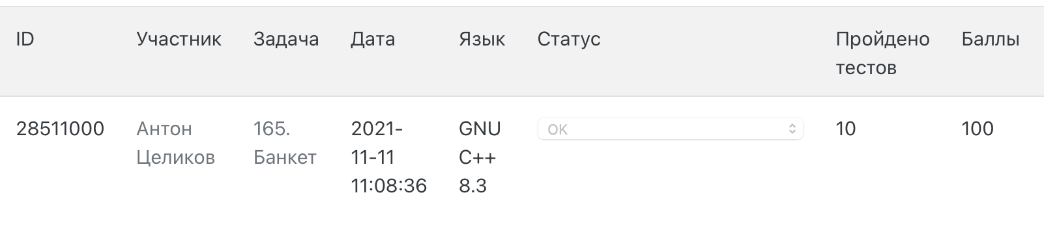

Листинг:

#include <algorithm>

#include <fstream>

#include <iostream>

#include <list>

#include <map>

#include <set>

#include <string>

#include <vector>

typedef std::string T_str;

typedef size_t T_person;

typedef std::list<T_person> T_bad_persons;

typedef std::map<T_person, T_bad_persons> T_bad_persons_for_person;

const T_person PERSON_MIN = 1;

enum T_table

{

NO_TABLE = 0,

TABLE_1,

TABLE_2

};

typedef std::map<T_person, T_table> T_table_of_person;

bool successfully_depth_first_search

(

T_person person,

const T_bad_persons_for_person& bad_persons_for_person,

T_table_of_person& table_of_person

)

{

if(table_of_person[person] == NO_TABLE)

{

table_of_person[person] = TABLE_1;

}

T_bad_persons_for_person::const_iterator

person_and_bad_persons_it = bad_persons_for_person.find(person);

if( person_and_bad_persons_it == bad_persons_for_person.end() )

{

return true;

}

T_bad_persons bad_persons = person_and_bad_persons_it->second;

for(

T_bad_persons::const_iterator

bad_person_it = bad_persons.begin();

bad_person_it != bad_persons.end();

++bad_person_it

)

{

if(

table_of_person[*bad_person_it] == table_of_person[person]

)

{

return false;

}

else if(

table_of_person[*bad_person_it] == NO_TABLE

)

{

table_of_person[*bad_person_it] = table_of_person[person] == TABLE_1

? TABLE_2

: TABLE_1;

if(

!successfully_depth_first_search

(

*bad_person_it,

bad_persons_for_person,

table_of_person

)

)

{

return false;

}

}//else if

}//for

return true;

}

bool successfully_to_seat

(

const T_bad_persons_for_person& bad_persons_for_person,

T_table_of_person& table_of_person

)

{

for(T_table_of_person::iterator person_and_table_it = table_of_person.begin();

person_and_table_it != table_of_person.end(); ++person_and_table_it)

{

if(person_and_table_it->second != NO_TABLE) continue;

if(

!successfully_depth_first_search

(

person_and_table_it->first,

bad_persons_for_person,

table_of_person

)

)

{

return false;

}

}

return true;

}

void input_persons_data

(

const T_str& ifile_name,

T_table_of_person& table_of_person,

T_bad_persons_for_person& bad_persons_for_person

)

{

std::ifstream ifile( ifile_name.c_str() );

int persons_total = 0;

ifile >> persons_total;

for(T_person person = PERSON_MIN; person <= persons_total; ++person)

{

table_of_person[person] = NO_TABLE;

}

int persons_pairs_total = 0;

ifile >> persons_pairs_total;

for(int i = 0; i < persons_pairs_total; ++i)

{

int L = 0;

ifile >> L;

int R = 0;

ifile >> R;

bad_persons_for_person[L].push_back(R);

bad_persons_for_person[R].push_back(L);

}

}

void print_persons_placement_at_tables

(

const T_str& ofile_name,

bool persons_are_successfully_seated,

const T_table_of_person& table_of_person

)

{

std::ofstream ofile( ofile_name.c_str() );

ofile << (

persons_are_successfully_seated

? "YES"

: "NO"

)

<< std::endl;

if(persons_are_successfully_seated)

{

for(T_table_of_person::const_iterator person_and_table_it = table_of_person.begin();

person_and_table_it != table_of_person.end(); ++person_and_table_it)

{

if(person_and_table_it->second == TABLE_1)

{

ofile << person_and_table_it->first

<< " ";

}

}

ofile << std::endl;

}

}

int main()

{

const T_str ifile_name = "input.txt";

const T_str ofile_name = "output.txt";

T_bad_persons_for_person bad_persons_for_person;

T_table_of_person table_of_person;

input_persons_data

(

ifile_name,

table_of_person,

bad_persons_for_person

);

bool bool_res = successfully_to_seat

(

bad_persons_for_person,

table_of_person

);

print_persons_placement_at_tables

(

ofile_name,

bool_res,

table_of_person

);

}